SQL Stored Procedures

🌟 Definition
# Source: AI Source: Provided by: [Data Path: Persons Table -> ID Column: 1, Name_En Column: Motasem Essam] -> From: [ChatGPT] on [6/11/2026]
A Stored Procedure is a named collection of one or more SQL statements that is stored inside the database and can be executed whenever needed.
Instead of writing the same SQL statements repeatedly, you can create a stored procedure once and call it multiple times.
Think of a stored procedure as a reusable SQL program.

🎯 Purpose
# Source: AI Source: Provided by: [Data Path: Persons Table -> ID Column: 1, Name_En Column: Motasem Essam] -> From: [ChatGPT] on [6/11/2026]
Stored Procedures are used to:
- Reuse SQL code
- Simplify complex database operations
- Improve performance by precompiling SQL statements (DBMS-dependent)
- Reduce network traffic by executing multiple statements in one call
- Improve security by restricting direct table access
- Encapsulate business logic inside the database

🧠 Simple Example
# Source: AI Source: Provided by: [Data Path: Persons Table -> ID Column: 1, Name_En Column: Motasem Essam] -> From: [ChatGPT] on [6/11/2026]
Instead of writing this query every time:
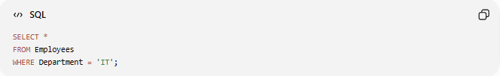
SELECT *
FROM Employees
WHERE Department = 'IT';
Create a stored procedure:
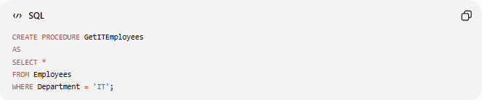
CREATE PROCEDURE GetITEmployees
AS
SELECT *
FROM Employees
WHERE Department = 'IT';
Execute it:
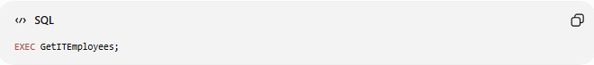
EXEC GetITEmployees;

📝 Basic Syntax (SQL Server)
# Source: AI Source: Provided by: [Data Path: Persons Table -> ID Column: 1, Name_En Column: Motasem Essam] -> From: [ChatGPT] on [6/11/2026]
Create a Stored Procedure
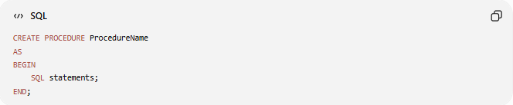
CREATE PROCEDURE ProcedureName
AS
BEGIN
SQL statements;
END;

Execute a Stored Procedure
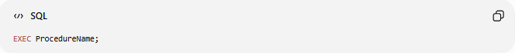
EXEC ProcedureName;

🔢 Components of a Stored Procedure
# Source: AI Source: Provided by: [Data Path: Persons Table -> ID Column: 1, Name_En Column: Motasem Essam] -> From: [ChatGPT] on [6/11/2026]
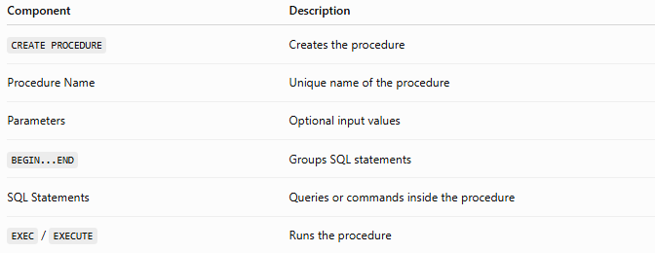
Component | Description
CREATE PROCEDURE | Creates the procedure
Procedure Name | Unique name of the procedure
Parameters | Optional input values
BEGIN...END | Groups SQL statements
SQL Statements | Queries or commands inside the procedure
EXEC / EXECUTE | Runs the procedure

📚 Example 1: Procedure Without Parameters
# Source: AI Source: Provided by: [Data Path: Persons Table -> ID Column: 1, Name_En Column: Motasem Essam] -> From: [ChatGPT] on [6/11/2026]
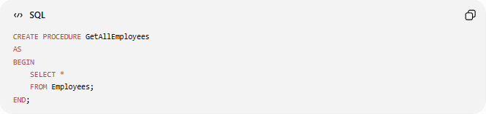
CREATE PROCEDURE GetAllEmployees
AS
BEGIN
SELECT *
FROM Employees;
END;
Execute:

EXEC GetAllEmployees;

📚 Example 2: Procedure with One Parameter
# Source: AI Source: Provided by: [Data Path: Persons Table -> ID Column: 1, Name_En Column: Motasem Essam] -> From: [ChatGPT] on [6/11/2026]
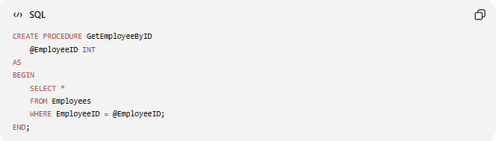
CREATE PROCEDURE GetEmployeeByID
@EmployeeID INT
AS
BEGIN
SELECT *
FROM Employees
WHERE EmployeeID = @EmployeeID;
END;
Execute:
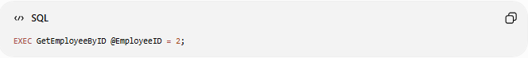
EXEC GetEmployeeByID @EmployeeID = 2;

📚 Example 3: Procedure with Multiple Parameters
# Source: AI Source: Provided by: [Data Path: Persons Table -> ID Column: 1, Name_En Column: Motasem Essam] -> From: [ChatGPT] on [6/11/2026]
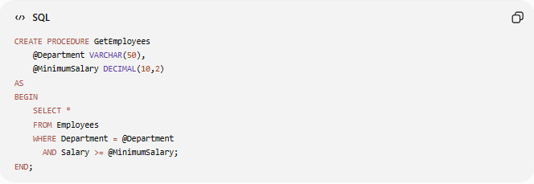
CREATE PROCEDURE GetEmployees
@Department VARCHAR(50),
@MinimumSalary DECIMAL(10,2)
AS
BEGIN
SELECT *
FROM Employees
WHERE Department = @Department
AND Salary >= @MinimumSalary;
END;
Execute:
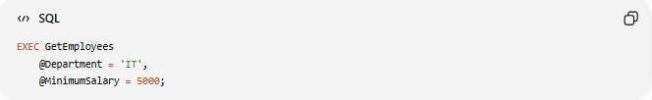
EXEC GetEmployees
@Department = 'IT',
@MinimumSalary = 5000;

📚 Example 4: Procedure with INSERT
# Source: AI Source: Provided by: [Data Path: Persons Table -> ID Column: 1, Name_En Column: Motasem Essam] -> From: [ChatGPT] on [6/11/2026]
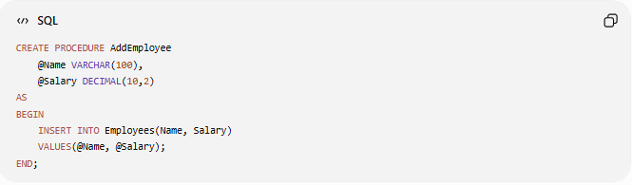
CREATE PROCEDURE AddEmployee
@Name VARCHAR(100),
@Salary DECIMAL(10,2)
AS
BEGIN
INSERT INTO Employees(Name, Salary)
VALUES(@Name, @Salary);
END;
Execute:
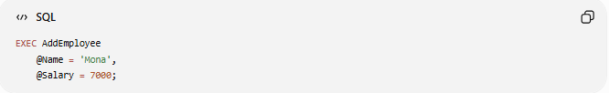
EXEC AddEmployee
@Name = 'Mona',
@Salary = 7000;

📚 Example 5: Procedure with UPDATE
# Source: AI Source: Provided by: [Data Path: Persons Table -> ID Column: 1, Name_En Column: Motasem Essam] -> From: [ChatGPT] on [6/11/2026]
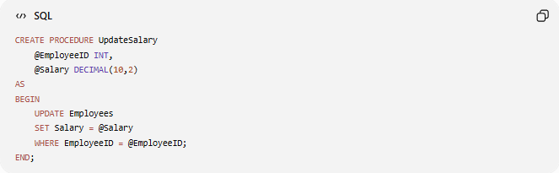
CREATE PROCEDURE UpdateSalary
@EmployeeID INT,
@Salary DECIMAL(10,2)
AS
BEGIN
UPDATE Employees
SET Salary = @Salary
WHERE EmployeeID = @EmployeeID;
END;
Execute:
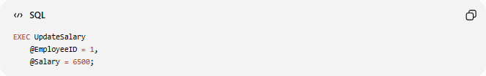
EXEC UpdateSalary
@EmployeeID = 1,
@Salary = 6500;

📚 Example 6: Procedure with DELETE
# Source: AI Source: Provided by: [Data Path: Persons Table -> ID Column: 1, Name_En Column: Motasem Essam] -> From: [ChatGPT] on [6/11/2026]
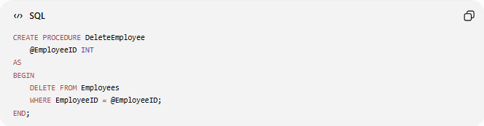
CREATE PROCEDURE DeleteEmployee
@EmployeeID INT
AS
BEGIN
DELETE FROM Employees
WHERE EmployeeID = @EmployeeID;
END;
Execute:
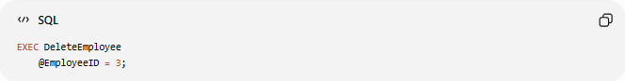
EXEC DeleteEmployee
@EmployeeID = 3;

🛠️ Complete Test Example

1️⃣ Create Table
# Source: AI Source: Provided by: [Data Path: Persons Table -> ID Column: 1, Name_En Column: Motasem Essam] -> From: [ChatGPT] on [6/11/2026]
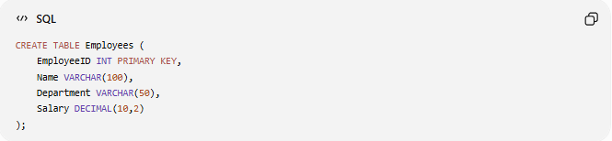
CREATE TABLE Employees (
EmployeeID INT PRIMARY KEY,
Name VARCHAR(100),
Department VARCHAR(50),
Salary DECIMAL(10,2)
);

2️⃣ Insert Sample Data
# Source: AI Source: Provided by: [Data Path: Persons Table -> ID Column: 1, Name_En Column: Motasem Essam] -> From: [ChatGPT] on [6/11/2026]
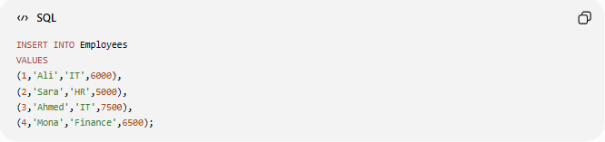
INSERT INTO Employees
VALUES
(1,'Ali','IT',6000),
(2,'Sara','HR',5000),
(3,'Ahmed','IT',7500),
(4,'Mona','Finance',6500);

3️⃣ Create Procedure
# Source: AI Source: Provided by: [Data Path: Persons Table -> ID Column: 1, Name_En Column: Motasem Essam] -> From: [ChatGPT] on [6/11/2026]
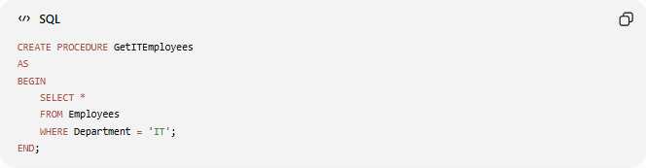
CREATE PROCEDURE GetITEmployees
AS
BEGIN
SELECT *
FROM Employees
WHERE Department = 'IT';
END;

4️⃣ Execute Procedure
# Source: AI Source: Provided by: [Data Path: Persons Table -> ID Column: 1, Name_En Column: Motasem Essam] -> From: [ChatGPT] on [6/11/2026]
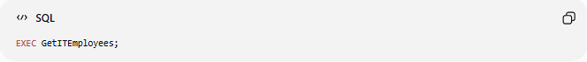
EXEC GetITEmployees;

5️⃣ Create Parameterized Procedure
# Source: AI Source: Provided by: [Data Path: Persons Table -> ID Column: 1, Name_En Column: Motasem Essam] -> From: [ChatGPT] on [6/11/2026]
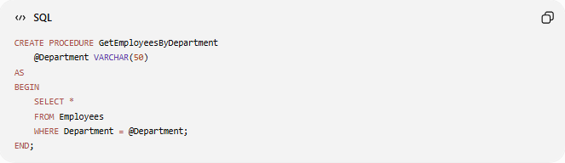
CREATE PROCEDURE GetEmployeesByDepartment
@Department VARCHAR(50)
AS
BEGIN
SELECT *
FROM Employees
WHERE Department = @Department;
END;

6️⃣ Execute Parameterized Procedure
# Source: AI Source: Provided by: [Data Path: Persons Table -> ID Column: 1, Name_En Column: Motasem Essam] -> From: [ChatGPT] on [6/11/2026]
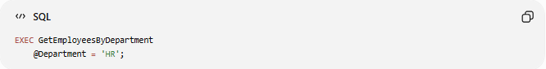
EXEC GetEmployeesByDepartment
@Department = 'HR';

📊 Stored Procedure vs SQL Query
# Source: AI Source: Provided by: [Data Path: Persons Table -> ID Column: 1, Name_En Column: Motasem Essam] -> From: [ChatGPT] on [6/11/2026]
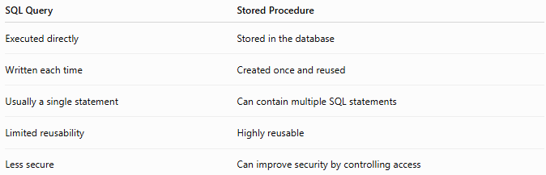
SQL Query | Stored Procedure
Executed directly | Stored in the database
Written each time | Created once and reused
Usually a single statement | Can contain multiple SQL statements
Limited reusability | Highly reusable
Less secure | Can improve security by controlling access

📊 Stored Procedure vs Function
# Source: AI Source: Provided by: [Data Path: Persons Table -> ID Column: 1, Name_En Column: Motasem Essam] -> From: [ChatGPT] on [6/11/2026]
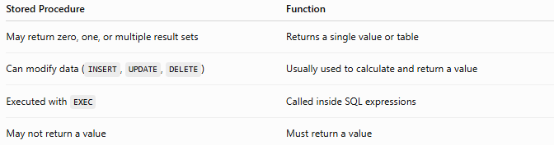
Stored Procedure | Function
May return zero, one, or multiple result sets | Returns a single value or table
Can modify data (INSERT, UPDATE, DELETE) | Usually used to calculate and return a value
Executed with EXEC | Called inside SQL expressions
May not return a value | Must return a value

⚠️ Important Notes
# Source: AI Source: Provided by: [Data Path: Persons Table -> ID Column: 1, Name_En Column: Motasem Essam] -> From: [ChatGPT] on [6/11/2026]
- Stored procedures are stored in the database.
- They can accept input parameters and, in many DBMSs, output parameters.
- A stored procedure can contain multiple SQL statements.
- Syntax differs slightly between SQL Server, MySQL, Oracle, and PostgreSQL.
- Stored procedures are commonly used in enterprise applications to centralize business logic.

🌍 Database Support
# Source: AI Source: Provided by: [Data Path: Persons Table -> ID Column: 1, Name_En Column: Motasem Essam] -> From: [ChatGPT] on [6/11/2026]
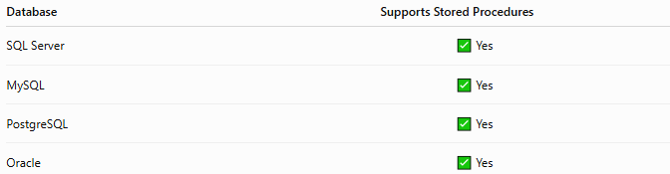
Database | Supports Stored Procedures
SQL Server | ✅ Yes
MySQL | ✅ Yes
PostgreSQL | ✅ Yes
Oracle | ✅ Yes
Note: The syntax for creating and executing stored procedures varies between database systems.

🔢 Stored Procedure Workflow
# Source: AI Source: Provided by: [Data Path: Persons Table -> ID Column: 1, Name_En Column: Motasem Essam] -> From: [ChatGPT] on [6/11/2026]
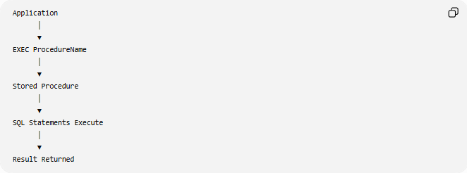
Application
│
▼
EXEC ProcedureName
│
▼
Stored Procedure
│
▼
SQL Statements Execute
│
▼
Result Returned

🧠 Simple Analogy
# Source: AI Source: Provided by: [Data Path: Persons Table -> ID Column: 1, Name_En Column: Motasem Essam] -> From: [ChatGPT] on [6/11/2026]
Imagine making coffee every morning.
Instead of repeating every step manually:
- Boil water
- Add coffee
- Add sugar
- Stir
You press a coffee machine button, and it performs all the steps automatically.
A Stored Procedure works the same way—you call it once, and it executes all the predefined SQL statements for you.

🧭 Summary
# Source: AI Source: Provided by: [Data Path: Persons Table -> ID Column: 1, Name_En Column: Motasem Essam] -> From: [ChatGPT] on [6/11/2026]
A SQL Stored Procedure is a reusable, named set of SQL statements stored in the database. It can accept parameters, perform operations such as SELECT, INSERT, UPDATE, and DELETE, and return results. Stored procedures improve code reusability, maintainability, security, and, in many cases, performance by keeping business logic close to the data.

